Week 4 Progress Report – AWS Generative AI Developer
Week: 4
Course: AWS Certified Generative AI Developer – Professional (AIP-C01)
Focus
• Continued learning Amazon Bedrock and Generative AI
• Understanding fine-tuning and model customization
• Introduction to Retrieval-Augmented Generation (RAG)
• Understanding vector stores, semantic search, and Knowledge Bases
• Learning about data chunking and embeddings
Resources Used
• Udemy – AWS Certified Generative AI Developer – Professional
• Amazon Bedrock
• AWS Documentation and learning resources
• Bedrock Knowledge Bases and RAG concepts
Hands-on / Course Activities
• Reviewed the Bedrock Playground
• Studied the Bedrock Converse API
• Learned about fine-tuning foundation models
• Reviewed upcoming topics related to RAG and Knowledge Bases
Topics Covered / Course Progress
Completed lessons shown in the screenshot:
• Hands-On with the Bedrock Playground
• More Depth on the Bedrock Converse API
• Fine-Tuning Foundation Models in Bedrock
Upcoming topics:
• Low-Rank Adaptation (LoRA) – How Fine-Tuning Works
• Retrieval-Augmented Generation (RAG)
• Vector Stores and Semantic Search
• Bedrock Knowledge Bases
• Hands-On with Knowledge Bases
• OpenSearch management
• Pre-Retrieval and Chunking Strategies
• Managing Chunking Strategies with Bedrock
• Optimizing Vector Stores and Embeddings
Learning Outcomes
• Improved understanding of Amazon Bedrock foundation models.
• Learned how the Converse API can be used to interact with models.
• Understood the purpose of fine-tuning foundation models.
• Started learning how RAG can provide additional information to Generative AI applications.
• Learned that vector embeddings and vector stores are important for semantic search and retrieval.
• Understood that Knowledge Bases can connect data with Generative AI applications. AWS documentation describes Knowledge Bases as a way to use retrieved information to improve generated responses.
Evidence Collected

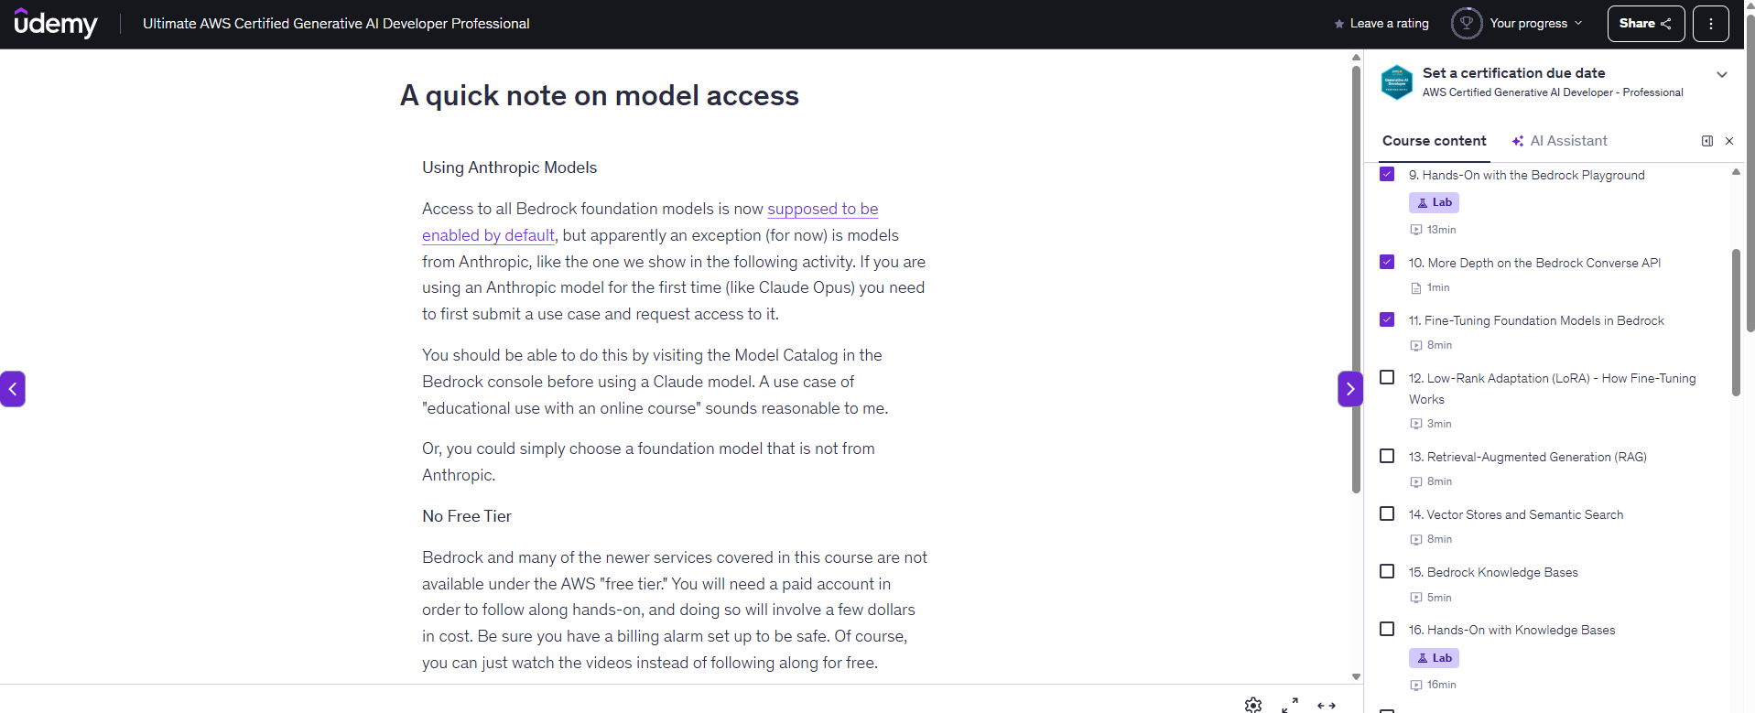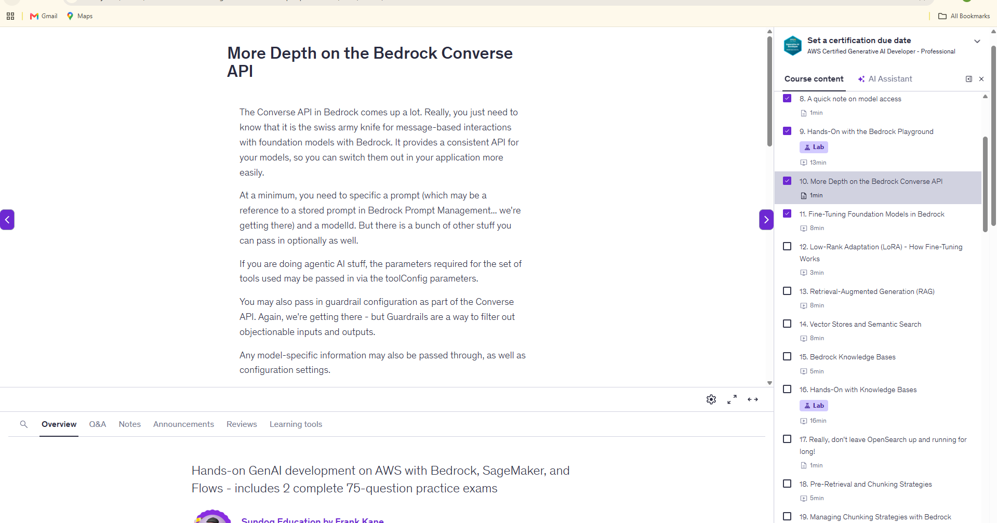
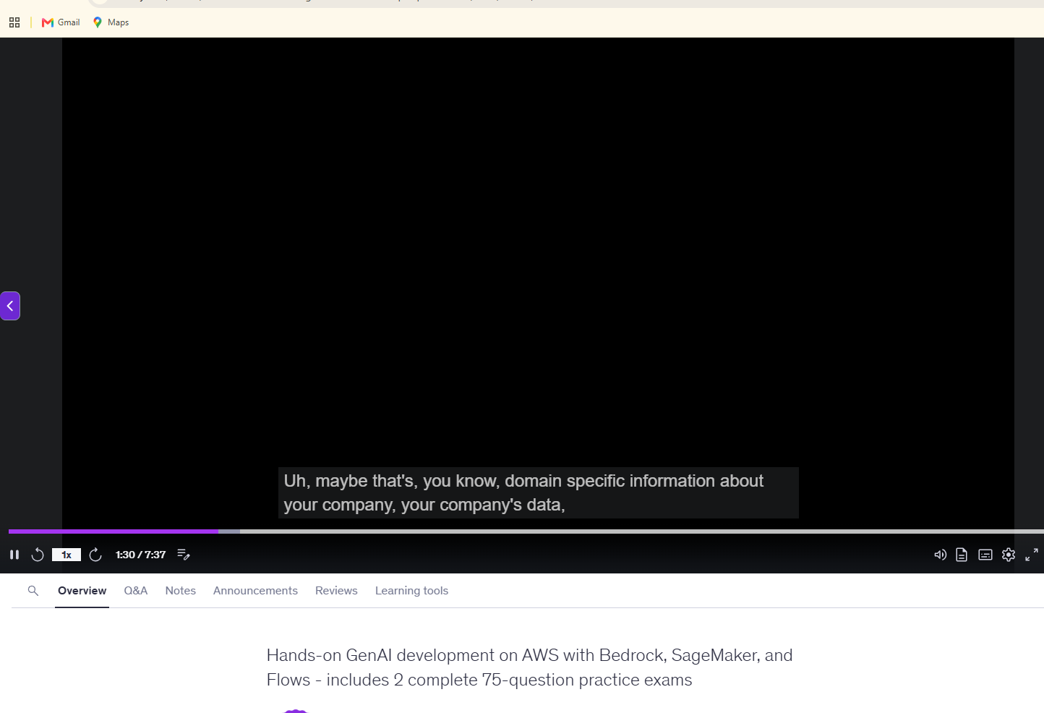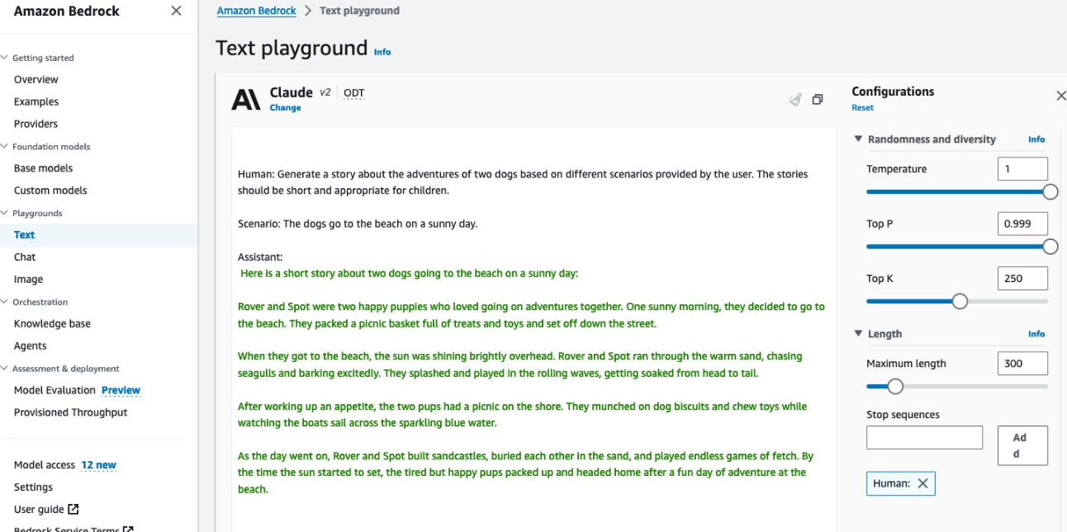
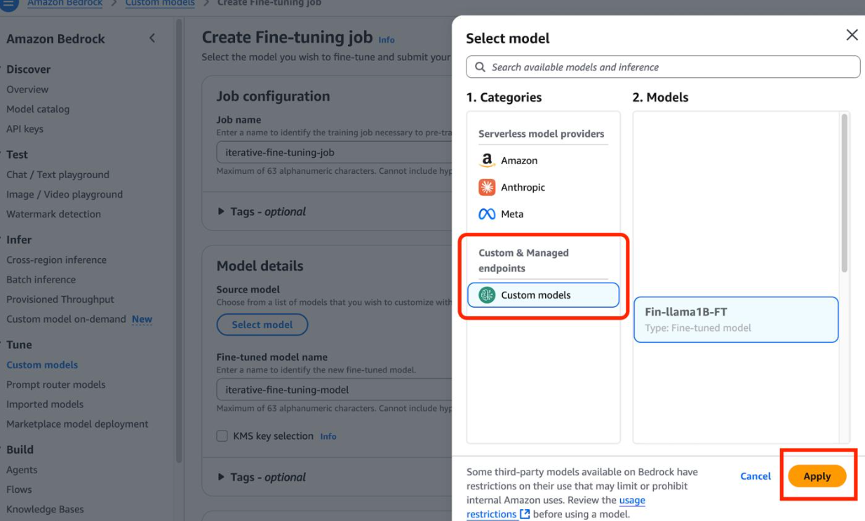
Amazon Bedrock – Practical Learning
Tasks Performed
• Practiced using the Bedrock Playground.
• Reviewed how the Converse API works.
• Studied foundation model fine-tuning.
• Reviewed the concepts that lead into RAG and Knowledge Bases.
• Studied how embeddings are used to represent data for semantic search.
RAG and Knowledge Base Concepts
• RAG retrieves relevant information from a data source and provides that information as context to a foundation model.
• Documents can be divided into smaller chunks and converted into vector embeddings.
• Vector stores are used to store and search these embeddings.
• Amazon Bedrock Knowledge Bases can be used to build RAG applications using connected data sources.
Issues Faced & Fixes
• Understanding the difference between fine-tuning and RAG – reviewed the course explanations and examples.
• Understanding vector embeddings and semantic search – studied how text is converted into vectors and compared for similarity.
• Understanding how Knowledge Bases connect data with Generative AI – reviewed the Bedrock Knowledge Bases workflow.
Next Week Plan
• Complete the LoRA lesson.
• Study Retrieval-Augmented Generation (RAG) in more detail.
• Learn vector stores and semantic search.
• Work with Amazon Bedrock Knowledge Bases.
• Complete the Knowledge Bases hands-on lab.
• Learn pre-retrieval, chunking strategies, and embedding optimization.

